Functional & Performance Testing Template
Model Performance Test
DATE | 26-06-26
PROJECT NAME | SB Stocks is a user-friendly web app built for stock market enthusiasts.
MAXIMUM MARKS

Test Scenarios & Results
Test Case ID | Scenario (What to test) | Test Steps (How to test) | Expected Result | Actual Result | Pass/Fail
FT-01 | Text Input Validation (e.g., topic, job title) | Enter valid and invalid text in input fields | Valid inputs accepted, errors for invalid inputs | 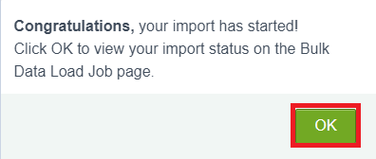 | 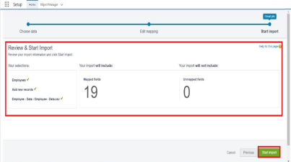
FT-02 | Number Input Validation (e.g., word count, size, rooms) | Enter numbers within and outside the valid range | Accepts valid values, shows error for out-of-range |  | 
FT-03 | Content Generation (e.g., blog, resume, design idea) | Provide complete inputs and click "Generate" | Correct content is generated based on input |  | 
FT-04 | API Connection Check | Check if API key is correct and model responds | API responds successfully |  | 
PT-01 | Response Time Test | Use a timer to check content generation time | Should be under 3 seconds |  | 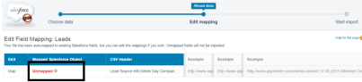
PT-02 | API Speed Test | Send multiple API calls at the same time | API should not slow down |  | 
PT-03 | File Upload Load Test (e.g., PDFs) | Upload multiple PDFs and check processing | Should work smoothly without crashing |  | 

